**SCHEDULING SYLLABUS ENG 201 BLOCK 6**

**MANY THINGS WILL CHANGE DEPENDING ON THE WEATHER!!!**

**I will try to be quick and flexible about weather conditions and will alert you by email or Moodle mail about any changes.**

**Always check your email twice or more a day for Moodle messages.**

*English 201: Introduces students to methods of reading, analyzing, and interpreting literature. Focus on understanding conventions and technical aspects of a literary work and on introduction to multiple genres of literature. Students do close reading and are introduced to additional methods of critical inquiry involving literature. Shows students how to apply critical and literary vocabulary, and to develop writing and research skills.*

*Note: Office hours Thursday 3:15-4:15 or by appointment. Talk with me after class to see if an appointment is necessary—or email me.*

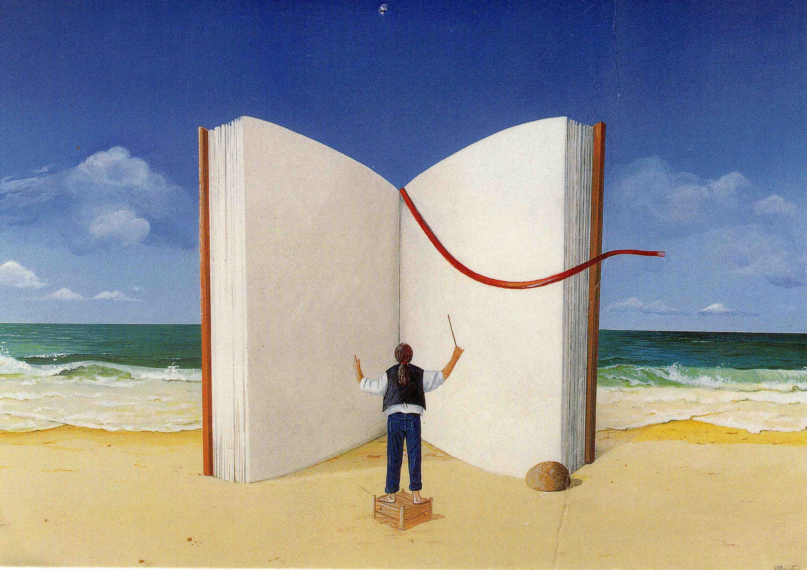

**WEEK ONE**

Monday February 11: 1-3 Introduction

Write letters to professor & peers responding to these questions. *“Why do you read?” “What do you read?” “What does reading do?” “What is literature?” “What does literature do in the world?” “Why are you here?” “What English courses have you taken at Cornell?” “Are you (or are you planning to become) an English major?” & “Describe a favorite reading experience in the past.”*

Screen *The Fantastic Flying Books of Mr. Morris Lessmore*. Discuss.

Read Stave 1 Dickens, *A Christmas Carol* aloud in class. Think about what role the narrator plays. Close Reading Guidelines and Stave 1.

Assign: Virginia Woolf “How Should One Read a Book?”

Barry, “Introduction” 3-21; Culler, Ch. 2 “What is Literature & Does it Matter?”

Dickens, *A Christmas Carol*, Stave 1-2. (Do not read Introduction yet; wait until you finish the book to read it.) 39-77. NOTE: OUR EDITION IS REQUIRED.

Tuesday February 12: MORNING 10-11. Go over syllabus and Discuss VW, Culler and Barry. If snow causes class to be cancelled, complete the readings for Dickens and catch up on reading.

Assign: Complete reading of *A Christmas Carol*; Begin work on close reading passage; then Read Introduction 9-30 and Appendix B: Child Labor, Education & the Workhouse. 187-207. Read Dickens letters, pp. 208-220. How does this background reading affect your understanding of your passage?

Wednesday February 13: 1-3 Discuss Dickens, Woolf, Barry, Culler.

Thursday February 14, 1-3 Screen *A Christmas Carol* 1951 (87 minutes) and begin discussion. Performers: Alastair Sim, Kathleen Harrison & Jack Warner; directed by Brian Desmond Hurst.

Assign: Read Barry “Context & Intertext” 49-50. Read “English & History” 171-180.

Assign: Barry, “Reading Poetry” 23-36

Friday February 15 1-3. Complete discussion of Dickens; *A Christmas Carol* in Context. Discussion of Want & Ignorance.

Assign: Work on Paper on Close Reading/Contextual Reading of passage in *A Christmas Carol*.

Bring FIRE!! To class.

WEEKEND

Saturday February 16

Sunday February 17

**WEEK TWO**

Monday February 18: paper due. Share insights with classmates for 10 minutes.

The Sonnet Project in Groups.

Assign: Read **both** Introductions to the Harlem Renaissance (on Moodle)

Tuesday February 19: MORNING 10-11 Sonnets project continued. Bring FIRE!! To class.

1-3 AFTERNOON: Screen *WIT* & begin discussion

Assign: Look over *FIRE!!* Read the Introduction (on line if not with your packet)

Read quickly through all the poems, and the stories: Zora Neale Hurston’s “Sweat,” Richard Bruce [Nugent] “Smoke, Lilies and Jade,” and Gwendolyn Bennett’s “Wedding Day” & look at the drawings. You will re-read these after the Rouse session. Think of topic you want to explore.

Wednesday February 20 Afternoon: 1-3 Jen Rouse on researching *FIRE!!*

Thursday February 21: 1-3 FIRE!!

Friday February 22: 1-3 Midterm short answer and short essay in class.

Take home question due by noon Saturday.

FIRE!! Research project over weekend. FIRE!! Research project due Monday.

WEEKEND

Saturday February 23

Sunday February 24

**WEEK THREE**

Monday February 24: Share Take Home Midterms and *FIRE!!* Research.

Assign: read all of *A Room of One’s Ow*n by Virginia Woolf. Read Introduction AFTER reading the text.

Tuesday February 25: MORNING 10-11: AROO.

*AFTERNOON CATCH UP ON READING!!*

Assign Culler, Ch 1 “What is theory?” Ch. 7 101-107 & Ch. 8

Male Privilege readings on Moodle

Assign: *Jacob’s Room* chapters 1-6.

Wednesday February 26: 1-3 *Jacob’s Room*

Assign: Complete *Jacob’s Room*

Assign Barry, Ch. 4 “Reading & Interpretation” 49-50. Ch 8, “Literary Criticism & Literary Theory” 127-145. Culler, Ch 3 “Literature & Cultural Studies” 42-54.

Thursday February 27: 1-3 *Jacob’s Room. Judith’s Room.* Judith Butler

Assign: *Two Old Women*

Friday February 28: 1-3: *Two Old Women*

Assign: *The Hen who dreamed that she could fly.* And *Ms Marvel*

WEEKEND

Saturday March 1

Sunday March 2

**WEEK FOUR**

Monday March 3: Discussions of *The Hen Who Dreamed She Could Fly* and *Ms. Marvel*.

Assign Final Exam Essay questions.

Tuesday March 4 MORNING 10-11 objective short answer/short essay final.

Wednesday March 5 MORNING Final Essay Exam due and shared with classmates. Celebration! Make Broadsides & Suminagashi for extra credit. Bring a passage or three from the course that you wish immortalized in a broadside. Print them up on laser printer to bring to class to suminagashi.

